5. December 2024

**Polyester textile recycling system realised with PURE LOOP’s ISEC evo**

**Project Re:Claim wins Plastics Industry Award 2024**

**The joint venture between the Salvation Army Trading Company (SATCoL) and Project Plan B, known as Project Re:Claim, uses an ISEC evo system from PURE LOOP to process used garments and textiles. The project, supported by the EREMA Group, represents Europe’s first commercial scale polyester textile recycling system.**

Ansfelden, 5. December 2024 - On 22November, the prestigious Plastics Industry Awards ceremony was held in London, UK. Project Re:Claim was recognised in the “Recycler of the Year” category. The partner companies accepted the award together with great enthusiasm.

Manfred Dobersberger, Managing Director of PURE LOOP, said: “We are incredibly proud of this recognition, which once again proves that going the extra mile truly pays off. The PURE LOOP team believed in taking new paths, and now we are being rewarded with this award. It’s a well-deserved acknowledgment of the hard work and determination our team has shown. Project Re:Claim is a true example of how successful collaboration between companies can drive forward textile recycling. I’m eager to see where this journey will take us.”

James Holmes, Production Director at Plan B, said: “We are thrilled to receive this prestigious award, which underscores the dedication and innovation that Project Plan B brings to the table. The success of Project Re:Claim is a testament to the power of collaboration and the relentless pursuit of sustainability. Our team at Plan B, in partnership with SATCoL and PURE LOOP, has worked tirelessly to create a groundbreaking recycling system that addresses the pressing issue of textile waste. This recognition motivates us to continue pushing the boundaries of what is possible in textile recycling. We are excited about the future and the positive impact we can make on the environment.”

Project Re:Claim is the first recycling system for textile polyester in Europe, specialising in post-consumer and post-industrial textiles. Further information about the project can be found in the PURE LOOP press release dated 7 November 2024:   
<https://www.pureloop.com/en/press/europes-first-polyester-textile-recycling-system-realised-with-pure-loops-isec-evo--96/>

**Pictures:**

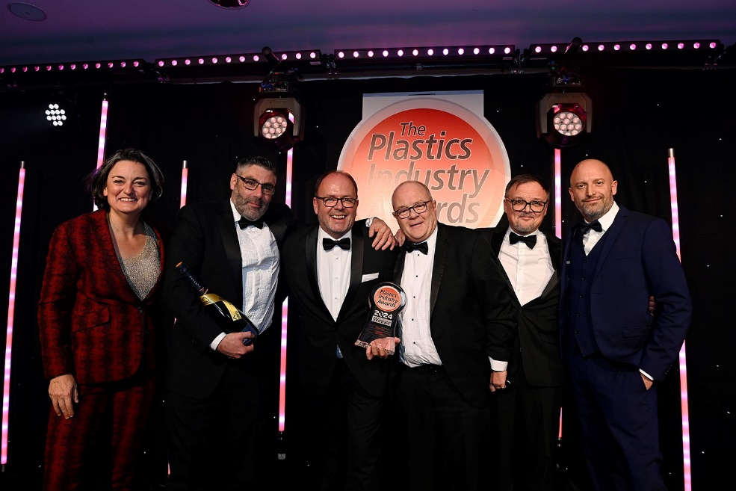 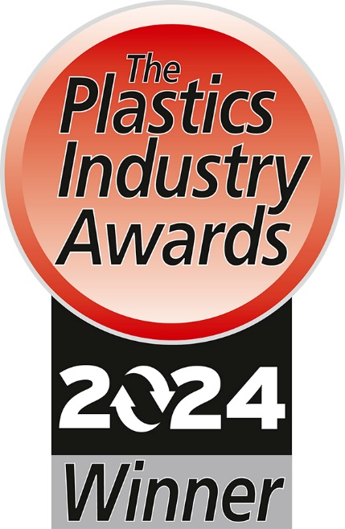

*Project Re:Claim has been awarded the Plastics Industry Award for 2024 in the “Recycler of the Year” category. In the picture from left: Zoe Lyons, British Comedian, George Barnett, Site Manager at SATCoL, Manfred Dobersberger, Managing Director of PURE LOOP, Mark Richardson, Sales Manager at Eurograv, James Holmes, Production Director at Plan B, James Stanton, Commercial Director of Distrupol*

**Image Copyright: Plastics Industry Awards**

**PURE LOOP**

PURE LOOP GesmbH, a subsidiary of EREMA Group GmbH, specialises in recycling clean production waste. The headquarters are in Ansfelden near Linz in Austria. The company’s innovative shredder-extruder technology offers maximum flexibility in processing high volume and highly tear-resistant industrial and post-industrial materials into recycled pellets. As a member of the EREMA Group, PURE LOOP has the advantage of the extensive experience, technological expertise and innovative strength of all the companies in the group.

**Eurograv**

Eurograv Limited is the authorised representative and distributor for PURE LOOP machines and components in the UK and Ireland. The company is based in Woking, Surrey. Eurograv offers a full range of services, supporting customers from installation through to commissioning to ensure the smooth operation of the technologies.

**Project Plan B**

Project Plan B specialise in garment design, with a focus on designing for circularity and recycling technologies – part of the company’s vision is to make the term ‘no end of use’ a reality for textiles. This vision was the beginning of the development of the technology with PURE LOOP, member of the EREMA Group, the leading global authority in plastic recycling, to create the world’s first polyester recycling system (technically known as a thermo-mechanical extrusion recycling system).

**Salvation Army Trading Company Ltd (SATCoL)**

Salvation Army Trading Company Ltd (SATCoL) is the trading arm (and a wholly owned subsidiary) of The Salvation Army in the UK and Republic of Ireland. SATCoL actively encourages the reuse and recycling of donated clothing and other household items through over 250 charity stores, and a nationwide network of around 9,000 clothing banks.

Each year, SATCoL diverts over 250 million items to good causes and reuses and recycles 67,000 tonnes of textiles. Through the reuse and recycling of clothing collected, SATCoL prevents over 453,000 tonnes of greenhouse gases from entering the atmosphere annually.

With the support of the British public, SATCoL has donated millions of pounds to The Salvation Army to help its work with vulnerable people in the UK (over £100 million has been donated in the last ten years). Salvation Army Trading Company Ltd is a registered company (2605817).

The Salvation Army is an international Christian church and registered charity which has been transforming lives for more than 150 years. Working in 134 countries worldwide, The Salvation Army offers friendship, practical help and support for people at all levels of need. In the UK and Ireland Territory, this work includes more than 650 community churches and social centres. Registered Charity Nos. 214779, 215174 and in Scotland SC009359, SC037691.

**For further information please contact:**

**Julia Krentl**

Corporate Communication

EREMA Group

Unterfeldstraße 3, 4052 Ansfelden, AUSTRIA

Phone: +43 732 3190-6092

E-Mail: public.relations@erema-group.com